Attach or Detach an External Storage Account.
Step 1: Open Storage Account in Azure Portal
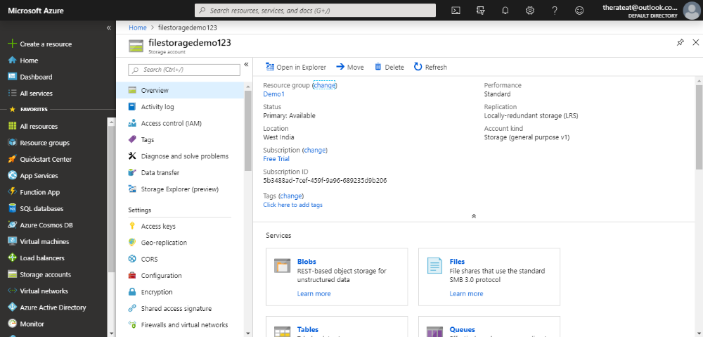

Step 2: In the settings section click on access keys.
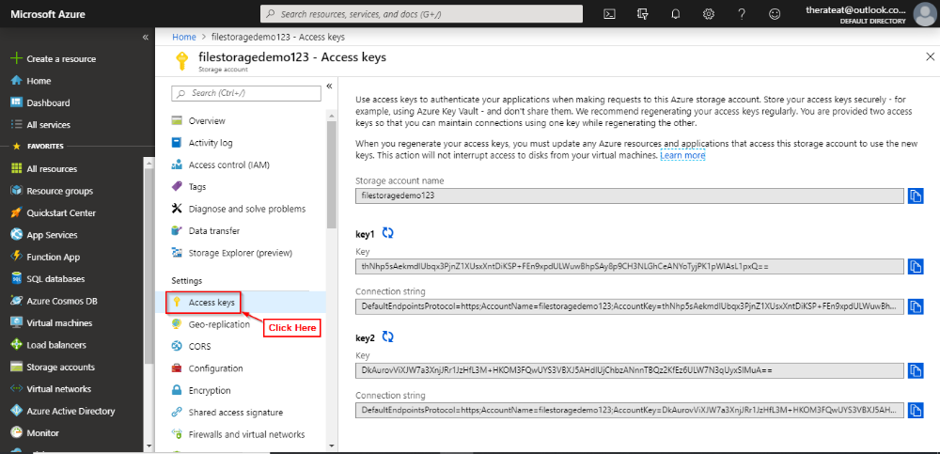
Step 3: Copy one of the keys.
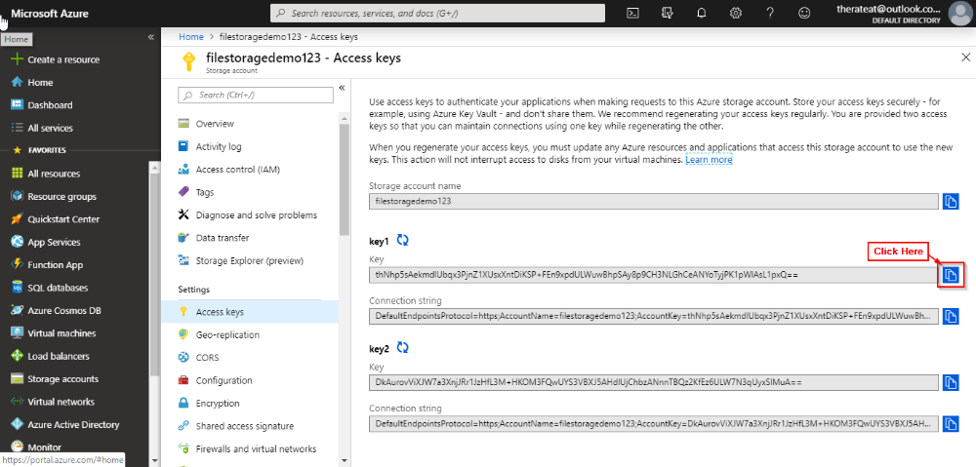
Step 4: Download the azure storage explorer on your local machine from here https://azure.microsoft.com/en-us/features/storage-explorer/.Open Azure Storage Explorer.
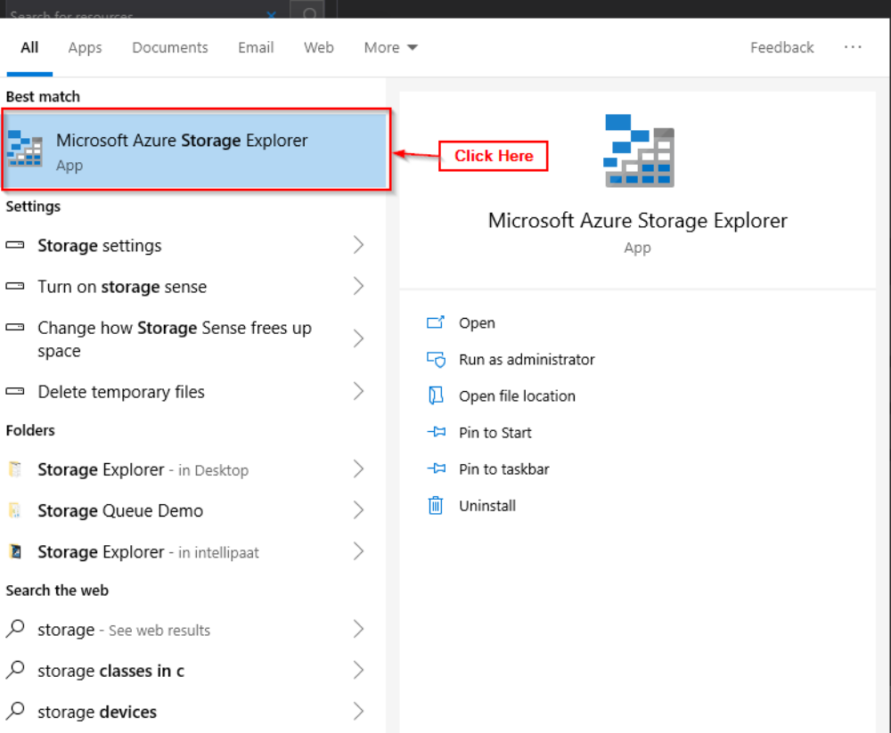
Step 5: Click on add account button.
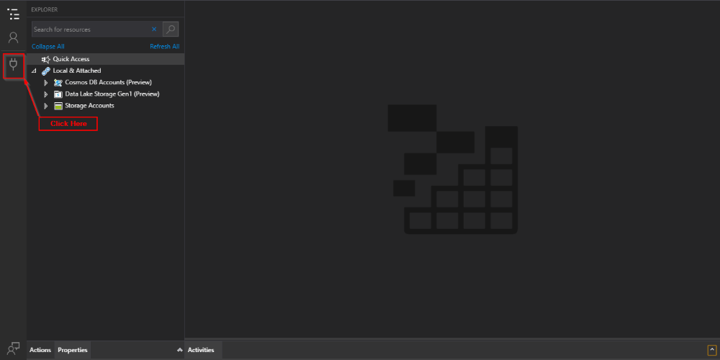
Step 6: Select use a storage account name and key and click next.
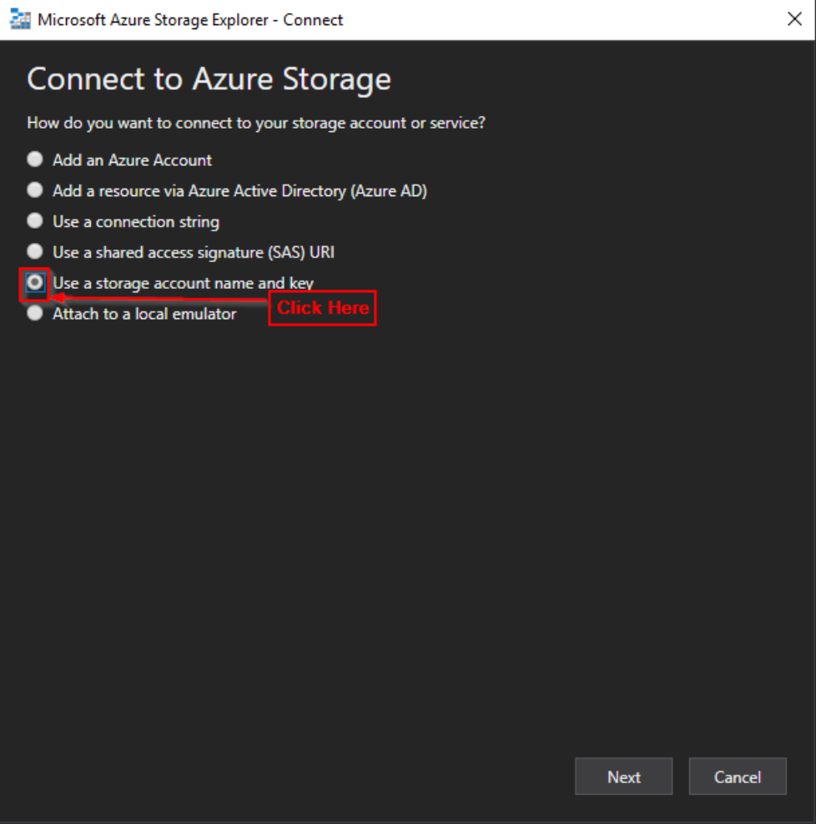
Step 7: Enter Display Name, Account Name and Account Key that you copied.
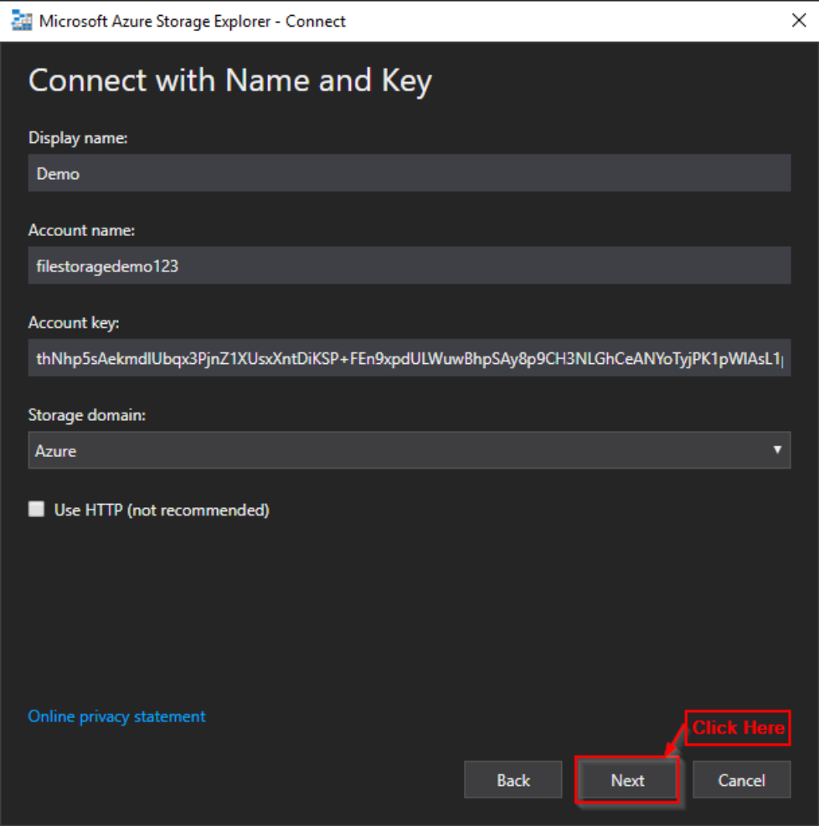
Step 8: Click on connect.
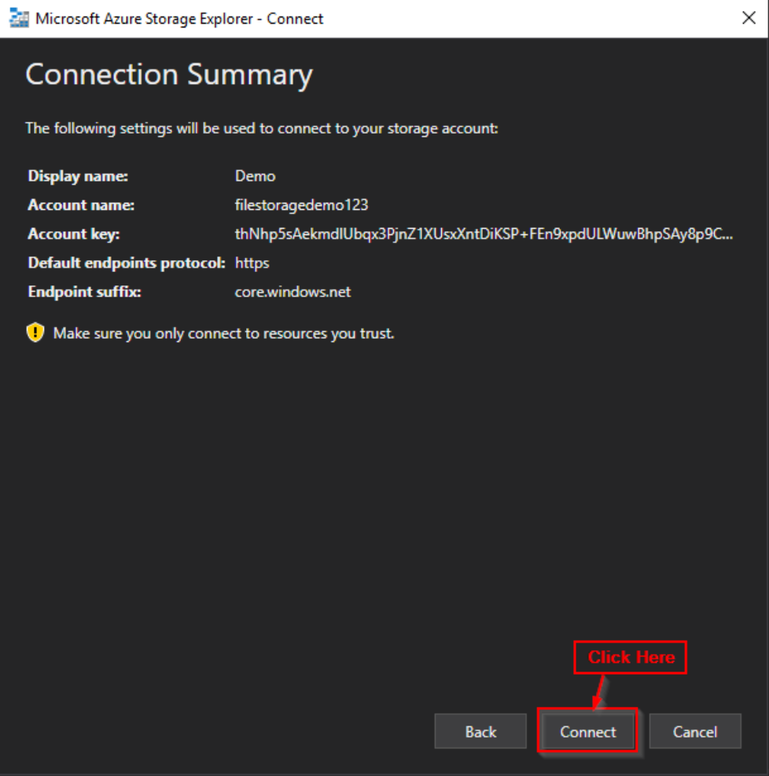
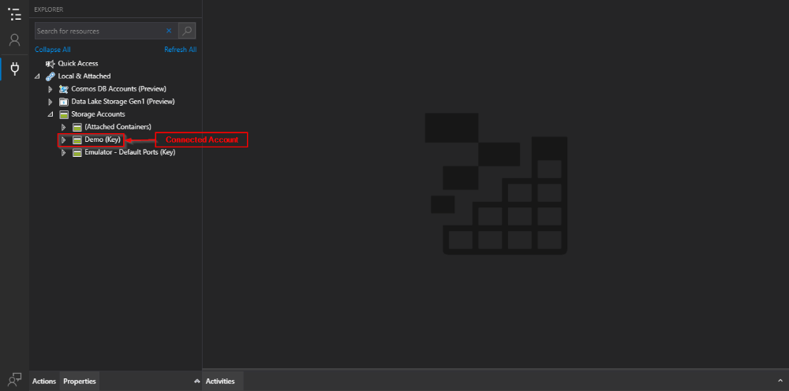

Detach External Storage Account
Step 1 Open Azure Storage Explorer.
Step 2 In the storage account section right click on the storage account you wish to detach.
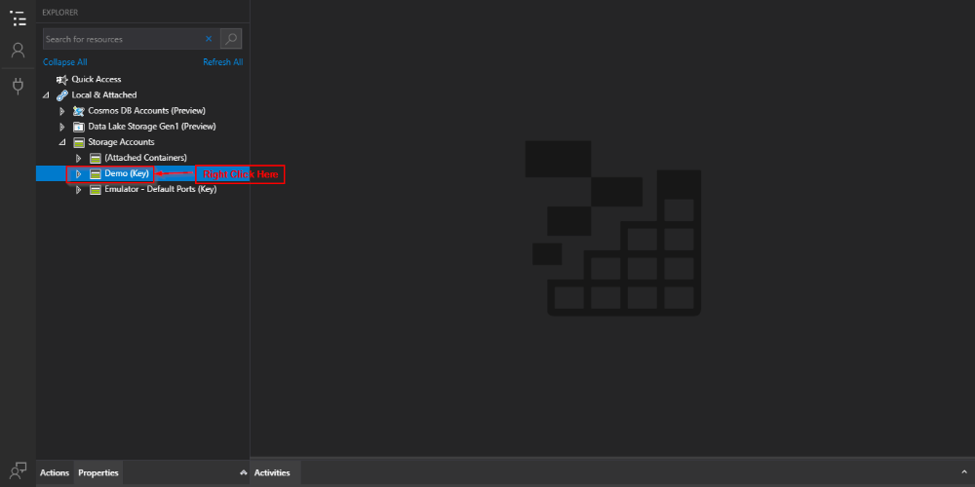
Step 3 Click on detach.
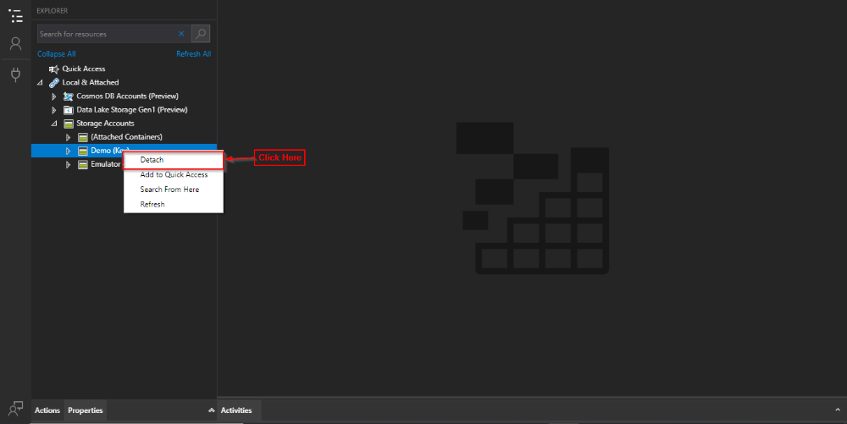
Step 4 Click on yes.
